Problem 1 :
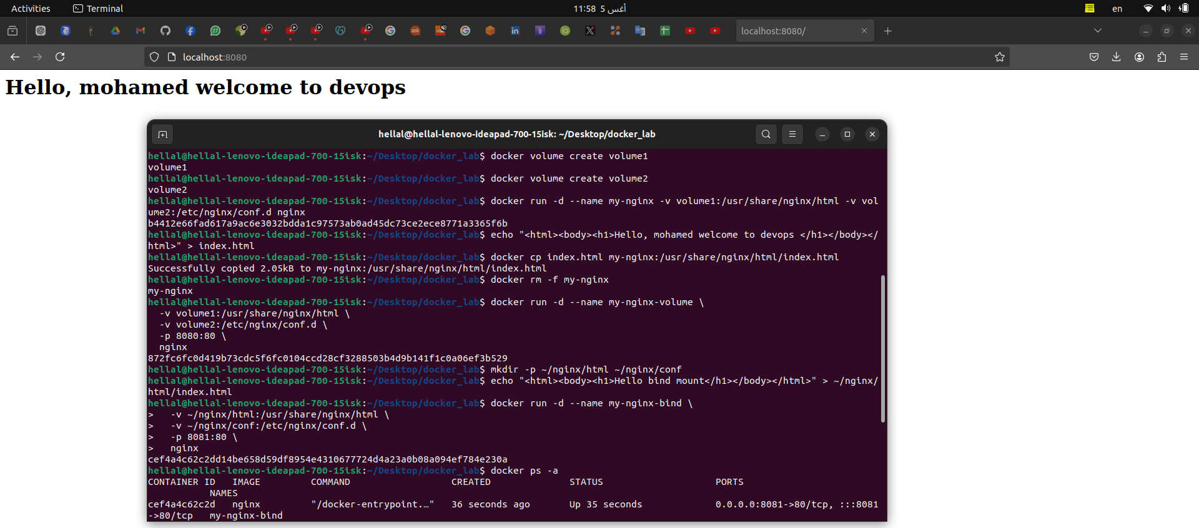

------------------------------------------------------------------------------------------------------------------------
problem 2:

1. Create the Dockerfile
# Stage 1: Build the React application
FROM node:8.15.1-alpine as build-stage

# Set the working directory in the container
WORKDIR /usr/src/app

# Copy package.json and package-lock.json
COPY package*.json ./

# Install dependencies
RUN npm --verbose install

# Copy the rest of the application code
COPY . .

# Build the React application
RUN npm run build
RUN npm install --force

# Stage 2: Serve the React application using a lightweight web server
FROM nginx:alpine

# Copy the build artifacts from the build stage
#COPY --from=build /app/build /usr/share/nginx/index.html

# Expose port 80 to access the application
EXPOSE 80
# Start Nginx
CMD ["nginx", "-g", "daemon off;"]

2. Create the Nginx Configuration File
cat <<EOF > nginx_conf/default.conf
server { listen 8080; location / { root /usr/share/nginx/html; index index.html; } }
3. Create the HTML File
<!DOCTYPE html> <html> <head> <title>My Custom Nginx Page</title> </head> <body> <h1>Hello from Nginx on Docker!</h1> </body> </html>
4. Build the Docker Image
docker build -t custom-nginx .
5. Run the Docker Container
docker run -d -p 8080:8080 --name my-nginx-container custom-nginx
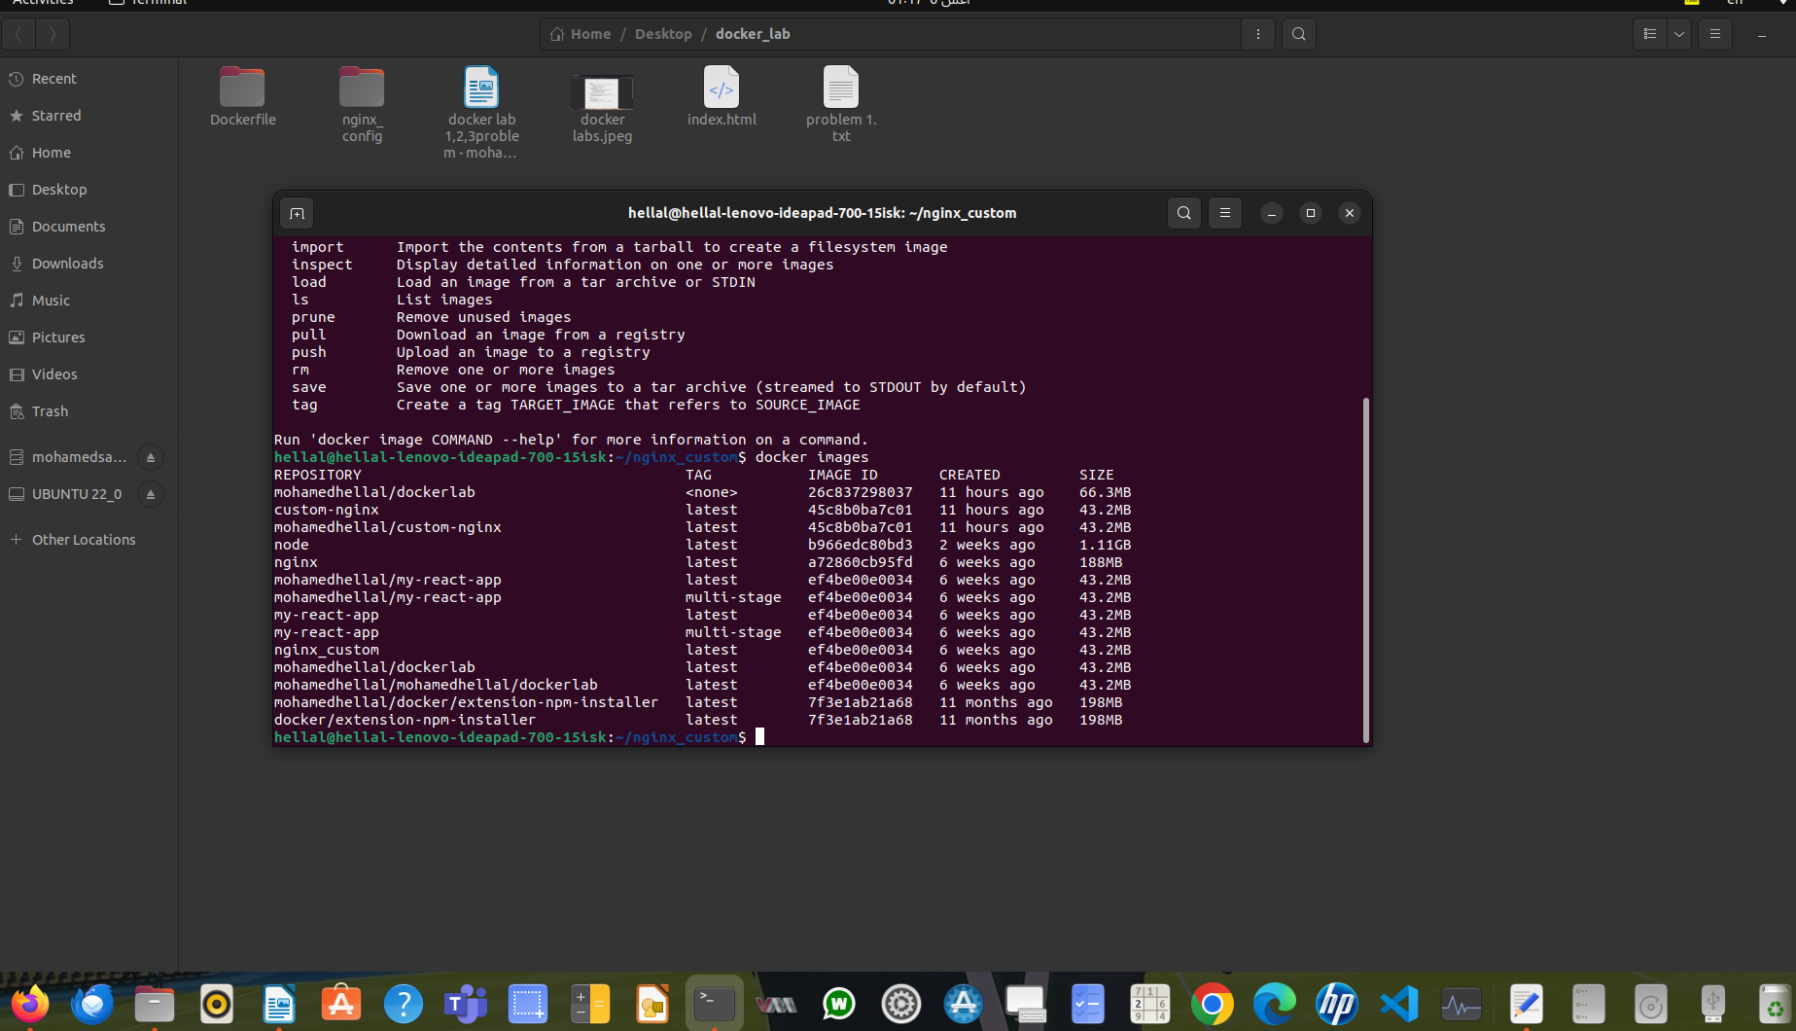

------------------------------------------------------------------

problem3:

1. Create a Dockerfile
# Stage 1: Build the React application
FROM node:8.15.1-alpine as build-stage

# Set the working directory in the container
WORKDIR /usr/src/app
# Copy package.json and package-lock.json
COPY package*.json ./
# Install dependencies
RUN npm --verbose install
# Copy the rest of the application code
COPY . .
# Build the React application
RUN npm run build
RUN npm install --force
# Stage 2: Serve the React application using a lightweight web server
FROM nginx:alpine
# Copy the build artifacts from the build stage
#COPY --from=build /app/build /usr/share/nginx/index.html
# Expose port 80 to access the application
EXPOSE 80
# Start Nginx
CMD ["nginx", "-g", "daemon off;"]

2. Build the Docker Image
docker build -t react-app .

Bonus: Multi-Stage Dockerfile
The Dockerfile provided above already uses multi-stage builds to create a smaller final image.
- Stage 1: Builds the React app using a Node.js image.
- Stage 2: Copies the build artifacts to a lightweight Nginx image.

